# What are Marginal Distributions?

**Marginal Distribution (Density) plots** are a way to extend your numeric data with side plots that highlight the density (histogram or boxplots work too).

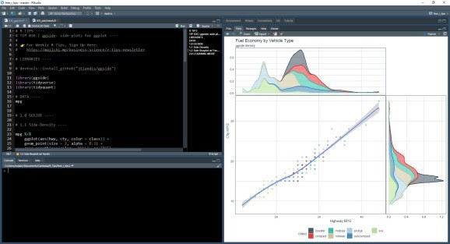

Linear Regression Marginal Distribution Side Plots. One of two plots we’re making today.

Marginal Distribution Plots were made popular with the seaborn jointplot() side-panels in Python. These add side plots that highlight distributions.

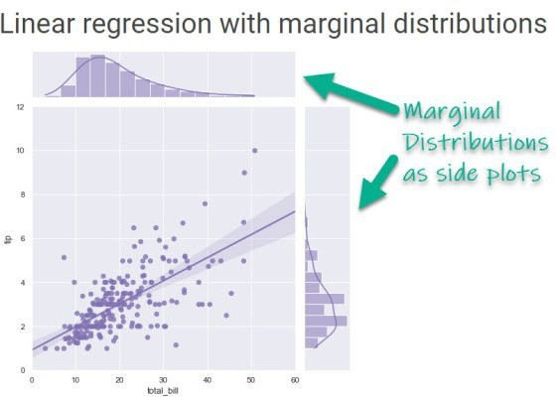

Seaborn’s jointplot() makes a Linear Regression with Marginal Distributions.

# How do we make them in ggplot2?

### Marginal distributions can now be made in R using ggside, a new ggplot2 extension. You

can make linear regression with marginal distributions using histograms, densities, box plots, and more. Bonus – The side panels are super customizable for uncovering complex relationships.

Here are **two examples** of what you can (and will) do in this tutorial! 

**Example 1:**

Linear Regression with Marginal Distribution (Density) Side-Plots (Top and Left)

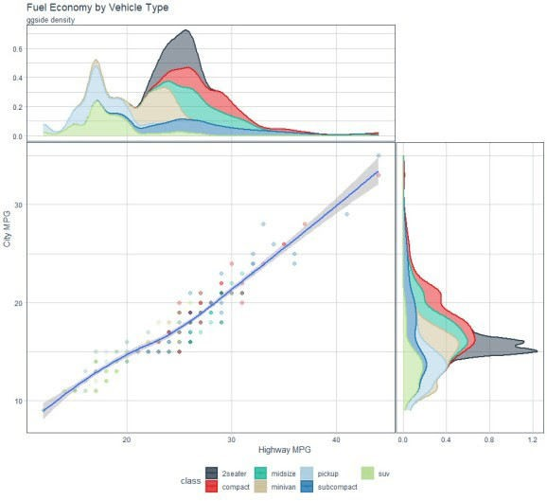

## Example 2:

Facet-Plot with Marginal Box Plots (Top)

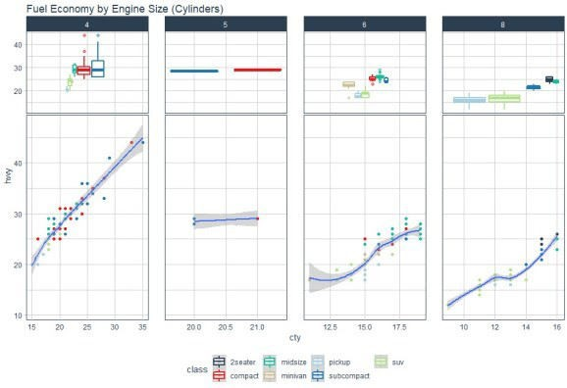

# Before we get started, get the Cheat Sheet

ggside is great for making marginal distribution side plots. But, you’ll still need to learn how to visualize data with ggplot2.

## Quick Example:

Download the Ultimate R Cheat Sheet. **Then Click the “CS” next to “ggplot2”** which opens the Data Visualization with Dplyr Cheat Sheet.

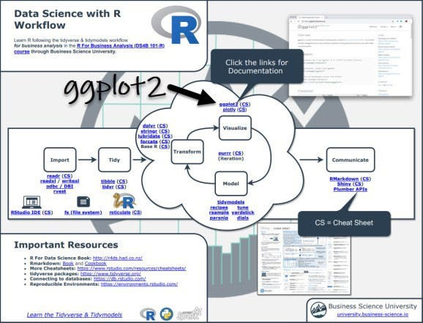

Now you’re ready to quickly reference ggplot2 functions.

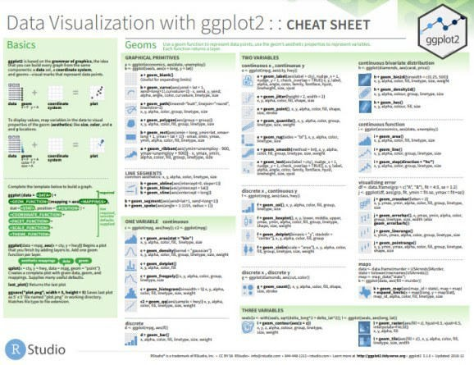

# Load Libraries & Data

The libraries we’ll need today are patchwork, ggridges, ggrepel, maps, tidyverse, and lubridate.

All packages are available on CRAN and can be installed with install.packages().

.

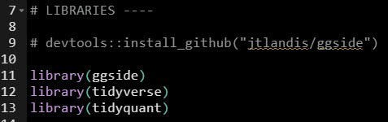

The dataset is the mpg data that comes with ggplot2.

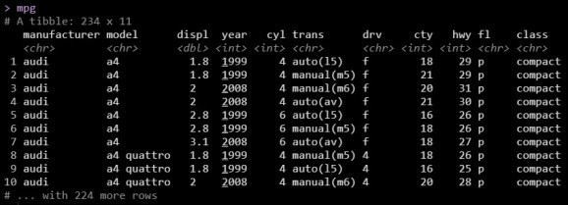

# SLinear Regression with Marginal Distribution Plot

**Replicating Seaborn’s jointdist() plot**

We’ll start by replicating what you can do in **Python’s Seaborn jointdist() Plot**. We’ll accomplish this with ggside::geom_xsidedensity()

## We set up the plot just like a normal ggplot.

Refer for:

ggplot() geom_point() geom_smooth()

## Next we add from ggside:

geom_xsidedensity() – Adds a side density panel (top panel).

geom_ysidedensity() – Adds a side density panel (right panel).

The trick is using the after_stat(density), which makes an awesome looking marginal density side panel plot. I increased the size of the marginal density panels with the theme(ggside.panel.scale.x).

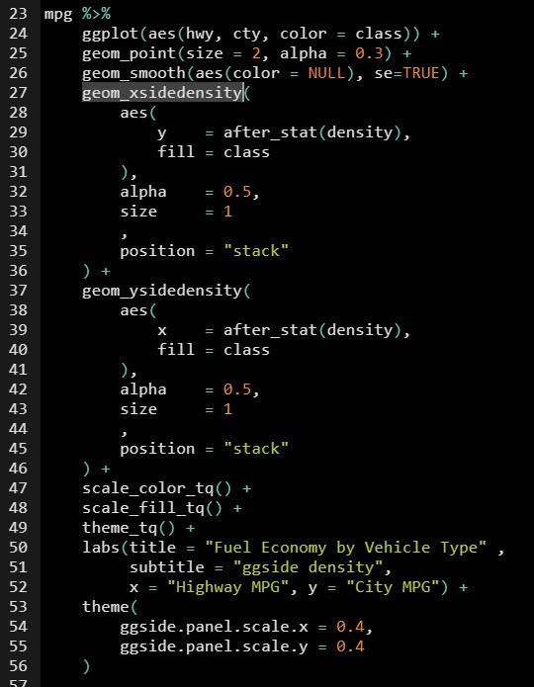

## Loess Regression w/ Marginal Density

We generate the regression plot with marginal distributions (density) to highlight key differences between the automobile classes. We can see:

Pickup, SUV – Have the **lowest** Highway Fuel Economy (MPG)

2seater, Compact, Midsize, Subcompact – Have the **highest** Highway Fuel Economy



# Plot . Faceted Side-Panels

Next, let’s try out some advanced functionality. I want to see how ggside handles faceted plots, which are subplots that vary based on a categorical feature. We’ll use the “cyl” column to facet, which is for engine size (number of cylinders).

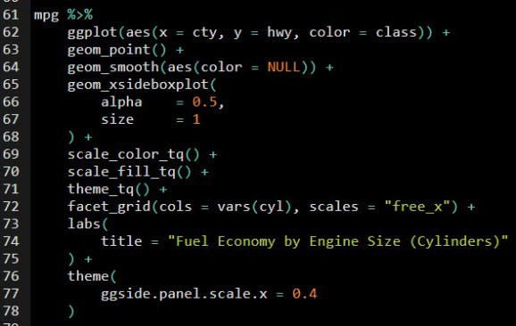

## Faceted Side Panels? No problem.

Awesome! I have included facets by “cyl”, which creates four plots based on the engine size. ggside picked up on the facets and has made 4 side-panel plots.



# Amazing. ggside just works.

### Congrats. You just quickly made two report-quality plots with ggplot2 and ggside. Excellent work.